Sierra Leone News: Inclusive education for children with disabilities
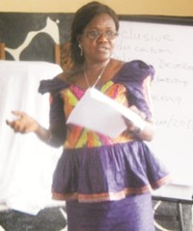
Frances Kamara,
Deputy Director of Education – East
Education for Children with Disabilities Network (ECDN) led by Sight Savers in collaboration with the Ministry of Education, Science, and Technology (MEST) has ended a regional stakeholders consultative meeting to make recommendations for the draft policy document and a strategy on inclusive education for children with disabilities.
Addressing the meeting, the Deputy Director of Education, Kenema District, Frances Kamara, called on participants to be frank and open-minded in their discussion reminding all that everyone is a potential candidate for a disability. She said the Ministry will ensure that no physically challenged person is left out in the inclusive education program. All will be put into mainstream educational institutions at all levels and the policy will empower the disabled.
The lead consultant, Professor Richard Rose, from the Faculty of Education and Humanities Centre for International Inclusive Pedagogy and Research, from University of Northampton UK, said, he is in the country together with other professors like Professor Philip Garner and Dr. Brenna Farrow to work on the policy. The aims of Inclusive Education asserts the rights of all children to receive an education that is appropriate to their needs. It also promotes the attendance of all students in age-appropriate classes in local schools, where they are encouraged and supported to participate in all aspects of the life of the school and to make both academic and social progress regardless of their needs or abilities
By Saffa B. Moriba
Friday June 30, 2017.

